Given the root of a binary tree, return *the lowest common ancestor of its deepest leaves*.

Recall that:

* The node of a binary tree is a leaf if and only if it has no children
* The depth of the root of the tree is 0. if the depth of a node is d, the depth of each of its children is d + 1.
* The lowest common ancestor of a set S of nodes, is the node A with the largest depth such that every node in S is in the subtree with root A.

**Note:** This question is the same as 865: <https://leetcode.com/problems/smallest-subtree-with-all-the-deepest-nodes/>

**Example 1:**

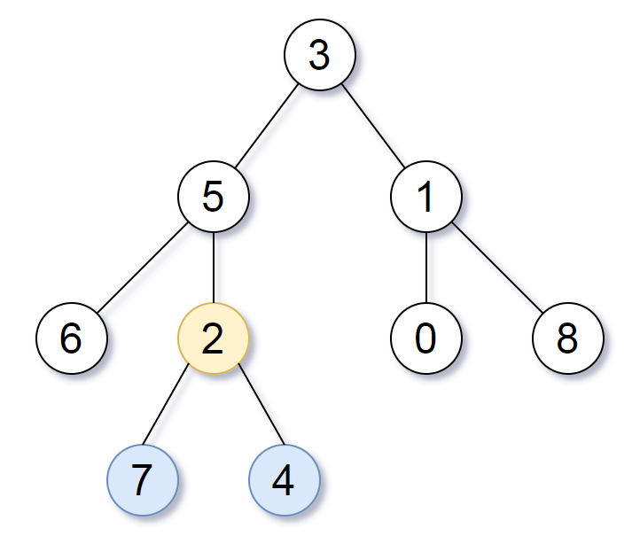

**Input:** root = [3,5,1,6,2,0,8,null,null,7,4]

**Output:** [2,7,4]

**Explanation:** We return the node with value 2, colored in yellow in the diagram.

The nodes coloured in blue are the deepest leaf-nodes of the tree.

Note that nodes 6, 0, and 8 are also leaf nodes, but the depth of them is 2, but the depth of nodes 7 and 4 is 3.

**Example 2:**

**Input:** root = [1]

**Output:** [1]

**Explanation:** The root is the deepest node in the tree, and it's the lca of itself.

**Example 3:**

**Input:** root = [0,1,3,null,2]

**Output:** [2]

**Explanation:** The deepest leaf node in the tree is 2, the lca of one node is itself.

**Constraints:**

* The number of nodes in the tree will be in the range [1, 1000].
* 0 <= Node.val <= 1000
* The values of the nodes in the tree are **unique**.